**Slide 1**

**Project overview :**

* **1.1 Project Name: EpicJourney**
* **1.2 Organization Name: tours and travels**
* **1.3 Team Members: Karan Barge , Pranav Chaudhari , Atharv Jagtap , Govindraj deosarkar**

**Slide 2**

**Introduction :**

**2.1 Operating Environment**

* **Hardware Configuration: (Provide hardware specs, e.g., servers, network devices)**
* **Software Configuration: (We used Programming Languages such as HTML , CSS , Bootsrap , Java Script)**

**Slide 3**

**Objectives :**

**1. User-Friendly Travel Planning**

* **Provide an easy-to-navigate platform that allows users to book travel services such as flights, hotels, and tour packages with minimal effort.**

**2. Comprehensive Travel Information**

* **Offer detailed information on various destinations, including must-visit places, travel tips, and local attractions to help users make informed decisions.**

**4. Seamless Booking Process**

* **Streamline the booking process for flights, hotels, and tours, ensuring a smooth, secure, and fast experience from start to finish.**

**6. Customer Reviews and Ratings**

* **Allow users to access and provide reviews and ratings for destinations, accommodations, and tour services to enhance trust and transparency.**

**8. Secure Payment Options**

* **Offer multiple secure payment methods, including credit/debit cards and digital wallets, to provide users with flexibility and confidence during transactions.**

**10. Customer Support and Assistance**

* **Offer 24/7 customer support through email section to help users resolve issues and answer their queries efficiently**

**Slide 4**

**Project Methodology Requirements:**

* **4.1 Questionnaire Structure / Survey Questions**

**1. What would be the most important feature you want on the EpicJourney website?**

**Answer:** Easy booking options for travel and simple to access would be my top priority.

**2. How do you prefer the website’s homepage to be designed?**

**Answer:** I would like a clean and minimalist design with prominent booking sections.

**3. How important is mobile responsiveness for you?**

**Answer:** It’s very important! I often plan trips on my phone, so the site needs to work well on mobile.

**4. What kind of service do you need for planning your journeys?**

**Answer:** I need best destination, budget range, types of travel (adventure, leisure), and reviews.

**5. How would you like the booking process to be handled on the site?**

**Answer:** I prefer a streamlined, one-click booking process that shows all necessary information like price, and services provided by company before finalizing.

**6. How important is it for the website to provide customer reviews?**

**Answer:** Extremely important. I always read reviews before booking, so I’d like them to be easily accessible and trustworthy.

**7. Would you like the ability to save multiple itineraries?**

**Answer:** Yes, it would be useful to book trip before making a decision.

**8. How would you prefer the payment options on the website to be handled?**

**Answer:** I’d like payment options, including credit cards, digital wallets

**9. Do you think integrating social media logins (like Facebook, Google) would enhance your user experience?**

**Answer:** Yes, I’d appreciate it. It makes signing in faster and easier, plus it allows me to share my trips with friends directly.

**10. Do you think a services section on trip and destination would be useful?**

**Answer:** yes, it is very important to know our customer that what kind of services we provide due to their journey.

**11. How much importance do you place on visual content, such as photos of destinations?**

**Answer:** Very important! High-quality images give me a much better sense of the destination and help me to decide.

* **4.2 Data Collection**

**Methods of collecting user feedback (e.g., Google Forms, direct interviews, analytics)**

1. **Ease of Use:**

* **"I’m really impressed with how user-friendly the website is. Navigating through different sections, like finding destinations and booking options, was seamless and intuitive."**

1. **Design and Layout:**

* **"The design is clean and modern, which I love. The use of images really brings the travel destinations to life, and the layout feels fresh and organized."**

1. **Personalized Features:**

* **"I particularly appreciate the personalized travel recommendations. It felt like the website understood my preferences and suggested exactly what I was looking for."**

1. **Overall Impression:**

**"Overall, I’m really happy with the website. It’s not just functional but also engaging. If I had to suggest one thing, it might be to include more interactive elements like destination videos, but otherwise, it’s fantastic!"**

**Slide 5**

**Methodology :**

**5.1 Fact-Finding Techniques**

**Surveys and Questionnaires:**

* Conduct online surveys or questionnaires targeting potential users to gather feedback on what features they expect from a travel website. Questions could include preferences for booking, favorite destinations, and desired travel services.

**Interviews with Travelers:**

* One-on-one or group interviews with frequent travelers can provide deep insights into user needs, travel behaviors, and pain points. This method allows for open-ended questions to understand user expectations for features like personalized recommendations or easy booking.

**Competitor Analysis:**

* Analyzing existing travel websites, such as their structure, features, and user feedback, will help identify best practices, gaps in services, and unique opportunities to differentiate EpicJourney from competitors.

**Website Analytics:**

* Use tools like Google Analytics or heat mapping tools on a prototype of the website to track user behavior and interaction patterns. This helps in identifying popular sections, drop-off points, and areas where users spend the most time, guiding further improvements.

**5.2 Tools Used**

* **HTML, CSS, and JavaScript**: Core technologies for building the structure, styling, and interactivity of the website.
* **Bootstrap**: A CSS framework that helps create a responsive and mobile-friendly design quickly.
* Google Analytics for tracking user behavior

**Slide 6**

**Project Analysis :**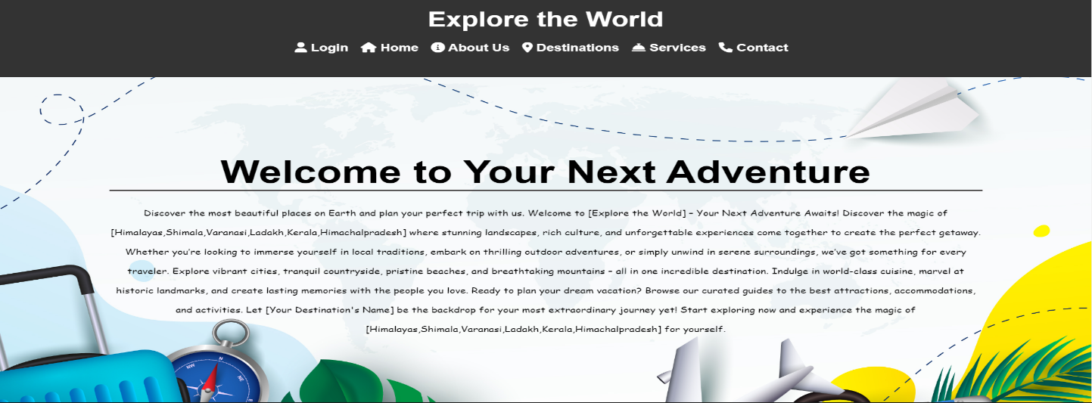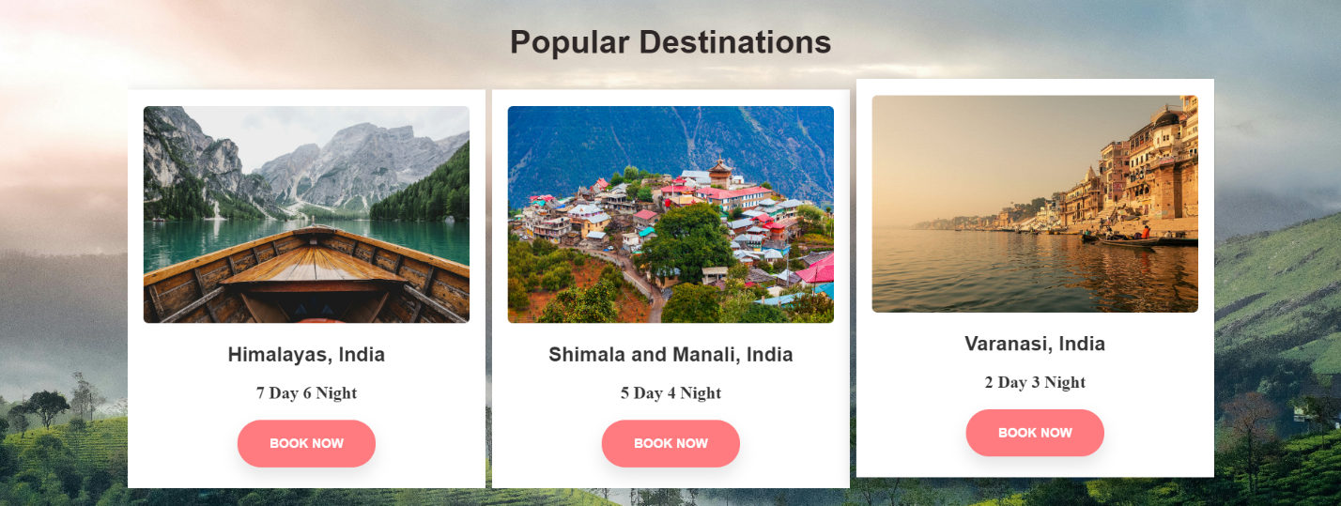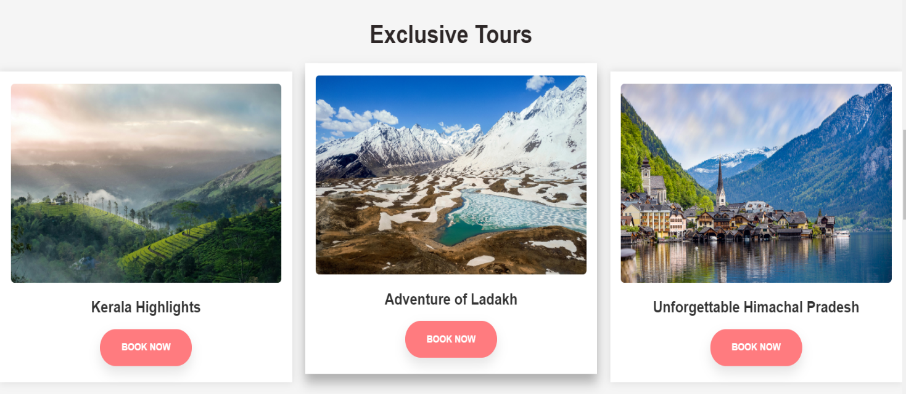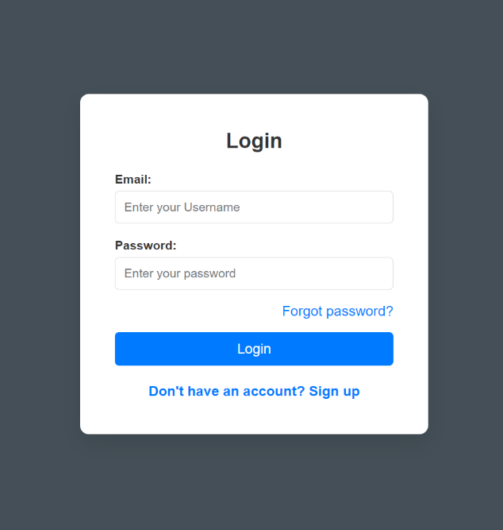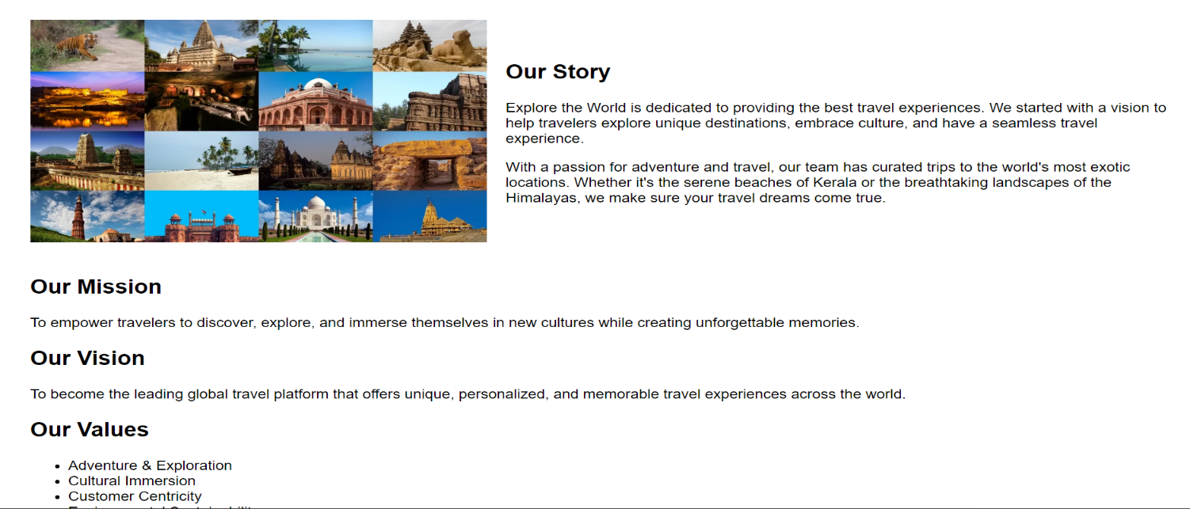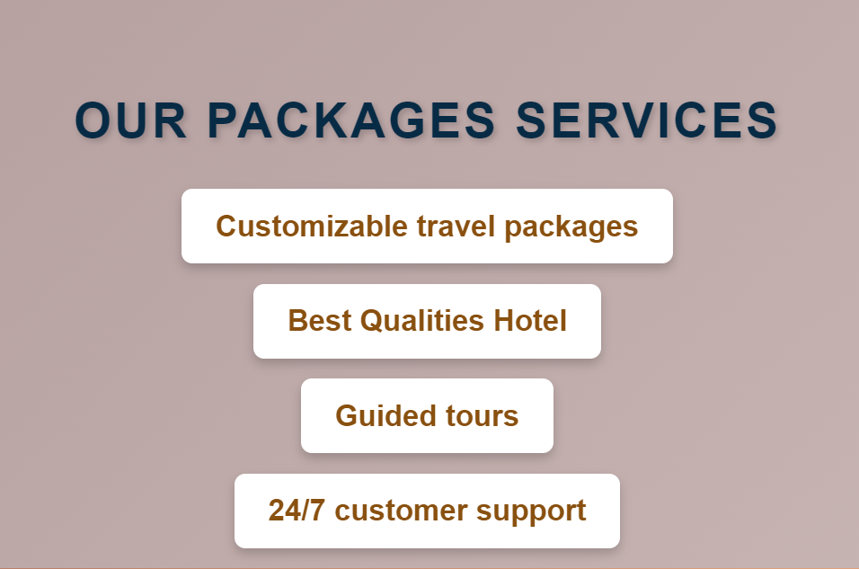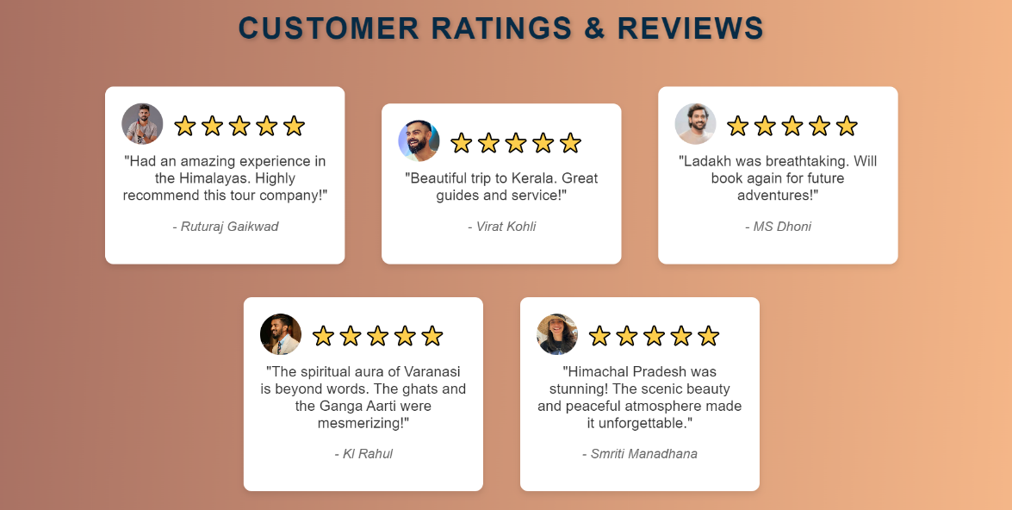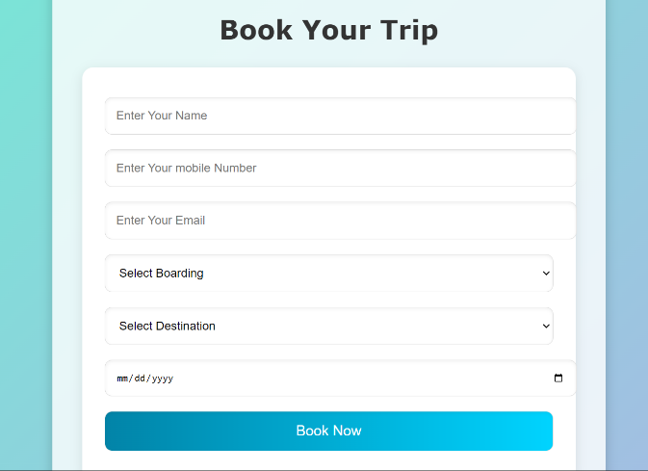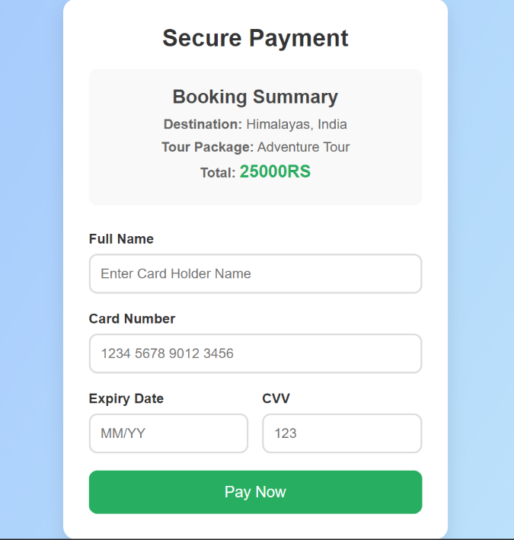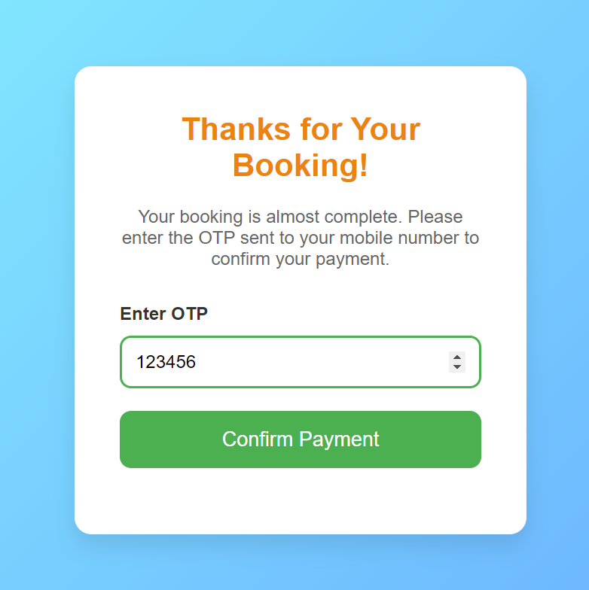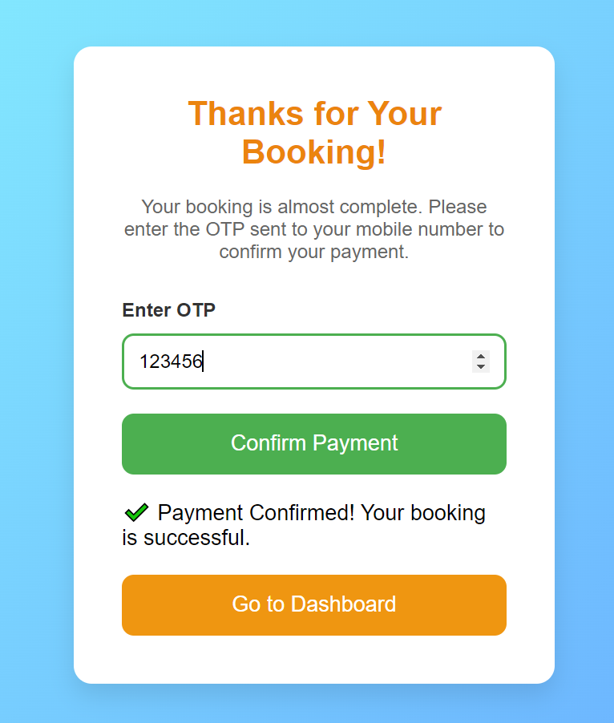



**Slide 7**

**Conclusion :**

The **EpicJourney** tours and travels website is designed to provide a seamless and user-friendly experience for travelers looking to explore new destinations and book their journeys with ease. With a clean and intuitive interface, the platform allows users to access comprehensive travel information, personalized recommendations, and streamlined booking options. By integrating advanced tools secure payment gateways, **EpicJourney** ensures that users can manage their travel plans efficiently from any device.

This project successfully addresses the needs of modern travelers by offering a range of features, including itinerary management, journey tracking, customer reviews, and travel deals. With future enhancements, and interactive destination guides, **EpicJourney** will continue to evolve and become a go-to platform for all travel-related services.

In conclusion, the **EpicJourney** website stands as a comprehensive and innovative solution for travel enthusiasts, providing them with everything they need in one convenient and visually engaging platform.